**First Query expected command:**

SELECT

SUM(cc.TRANSACTION_VALUE), b.BRANCH_ZIP

FROM

CDW_SAPP_HIVEDB.CREDITCARD cc JOIN CDW_SAPP_HIVEDB.BRANCH b

ON (cc.BRANCH_CODE=b.BRANCH_CODE)

GROUP BY

b.BRANCH_ZIP

ORDER BY

SUM(cc.TRANSACTION_VALUE) DESC

limit 20;

**First Query Expected Hive Visualization**

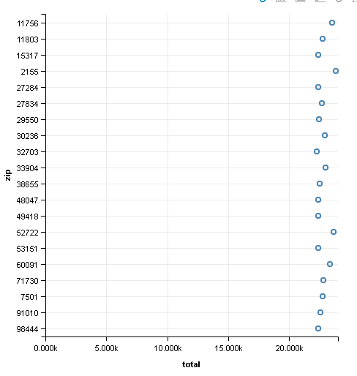

**Second Query Expected Command:**

SELECT

SUM(cc.TRANSACTION_VALUE), t.QUARTER, cc.TRANSACTION_TYPE

FROM

CDW_SAPP_HIVEDB.CREDITCARD cc JOIN CDW_SAPP_HIVEDB.TIME t ON (cc.TIMEID = t.TIMEID)

WHERE

t.YEAR = 2018

GROUP BY

t.QUARTER, cc.TRANSACTION_TYPE;

**Second Query Expected Hive Visualization**

